# Section 13:1: The First Teaching Tour and the First Rainy Season

In Section 4, we explored how the ascetic Siddhartha abandoned extreme austerities and cultivated deep meditation, ultimately attaining perfect enlightenment (Sammāsambuddha). For approximately five to seven weeks after his awakening, he remained near the site of his enlightenment—now known as Bodh Gaya—at Uruvelā, immersed in the bliss of liberation.

During this period, upon the invitation of Brahma Sahampati, he resolved to share his profound realization with the world and began his journey as a teacher of the Dhamma.

From Sections 4 to 12, we have described the extraordinary qualities of the Buddha. In this section (13.1) and the ones that follow (13.2, etc.), we will explore the locations where the Buddha spent his rainy seasons and the significant events that took place during those times (see Section 13: Introduction for an overview).

This section focuses on the first year after the Buddha’s enlightenment and how he spent his first rainy season (vassa). Here, we witness the Buddha—not only as a newly awakened Tathāgata but also as a compassionate teacher—setting forth on his great mission. At the age of thirty-five, with boundless wisdom and infinite compassion, he was eager to share the path to liberation for the welfare and happiness of all beings.

In **Section 4**, we explored how the ascetic Siddhartha abandoned extreme austerities and cultivated deep meditation, ultimately attaining perfect enlightenment (*Sammāsambuddha*). For approximately five to seven weeks after his awakening, he remained near the site of his enlightenment—now known as Bodh Gaya—at Uruvelā, [1] immersed in the bliss of liberation.

During this period, upon the invitation of Brahma Sahampati, [2] he resolved to share his profound realization with the world and began his journey as a teacher of the Dhamma.

From **Sections 4 to 12**, we have described the extraordinary qualities of the Buddha. In this section *(13.1)* and the ones that follow (13.2, etc.), we will explore the locations where the Buddha spent his rainy seasons and the significant events that took place during those times (see Section 13: Introduction for an overview).

This section focuses on the **first year** after the Buddha’s enlightenment and how he spent his **first rainy season (*vassa*)**. Here, we witness the Buddha—not only as a newly awakened *Tathāgata* but also as a compassionate teacher—setting forth on his great mission. At the age of thirty-five, with boundless wisdom and infinite compassion, he was eager to share the path to liberation for the welfare and happiness of all beings.

# The Buddha’s First Teaching Tour

After his supreme awakening, the newly enlightened Buddha, filled with boundless compassion, reflected:

"*Who should I teach first? Who will quickly understand this profound Dhamma*?" [3]

## Honoring His Former Teachers

With the all-seeing wisdom of a Buddha, he surveyed the world and perceived beings with little dust in their eyes and others with much—some easy to guide, others difficult—some with sharp faculties, others with dull. Out of deep gratitude, he first thought of his former teachers, **Āḷāra Kālāma and Uddaka Rāmaputta**, [4] knowing they possessed great wisdom and would readily grasp the Dhamma. However, upon looking for them, he realized that both had passed away. [5]

## Remembering the Five Ascetics [6]

The Buddha then turned his thoughts to the **five ascetics** who had faithfully attended to him during his years of striving. Filled with appreciation for their past kindness, he reflected:

*"They supported me in my quest; they rendered me great service. Let me teach them first. But where are they now?"*

With his divine eye, he saw that they were residing in **Benares, at the Deer Park in Isipatana**. [7] Moved by compassion, the Buddha resolved to set forth on his first teaching journey—to share the truth of enlightenment with them.

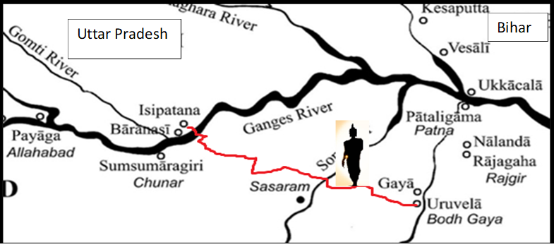

**Map showing the First walking tour of the Buddha**

The Blessed One walked this journey alone from then Uruvelā (present day Bodh Gaya) to the Deer Park in Isipatana, Banaras. Distance from Bodh Gaya to Varanasi by road is about 255 km [8]

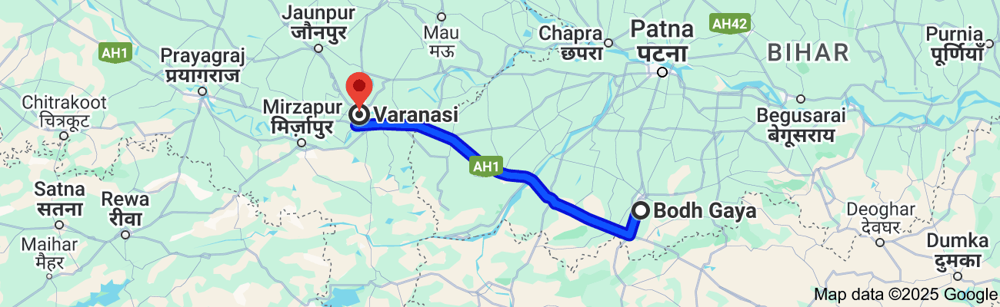

**Present day road map (Google) showing the route from Bodh Gaya to Banaras**

# The Beginning of the First Teaching Tour: The Road to Isipatana

After dwelling in the bliss of liberation at Uruvelā for as long as he wished, the Blessed One set forth on his first journey—walking towards **Benares**, in search of the five ascetics. [9]

According to some other source:

*"In the month of Asāḷha, he began his journey—18-yojana walk on foot."* [10]

## The Buddha’s Encounter with Upaka, the Ājīvaka Ascetic [11]

As the Buddha walked along the high road from Bodh Gaya toward Gaya, he encountered **Upaka**, an Ājīvaka ascetic, approaching from the opposite direction. Struck by the Buddha’s radiant presence, Upaka paused and exclaimed:

*"Sir, your senses are serene, and your complexion shines with a radiant glow. Under whose guidance have you gone forth? Who is your teacher, and whose teaching do you follow?" [12]*

With unshakable confidence, the Blessed One replied: [13]

**"I am the Victor, the Knower of all.**  
**Abandoning all, I am unstained by anything.**  
**Through my own insight, I have realized the end of craving—**  
**So who should I call my teacher?"**

**"I have no teacher; no one like me exists.**  
**There is no equal to me in all the world—**  
**For I am the Perfected One, the Supreme Teacher."**

Then, proclaiming his great mission, he declared:

**"I go to the city of Kāsi,**  
**To set rolling the wheel of Dhamma.**  
**In this world, lost in darkness,**  
**I shall sound the drum of the Deathless."**

Awed but not fully understanding, Upaka said, **"You must be a Universal Victor (Anantajina)."**

The Buddha affirmed:

**"True victors are those like me,**  
**Who have conquered the taints of defilement.**  
**I have vanquished all evil states—**  
**Therefore, Upaka, I am a true Victor."**

Yet, unable to recognize the greatness of the One standing before him, Upaka simply responded, **"May it be so, friend,"** and took another path.

.

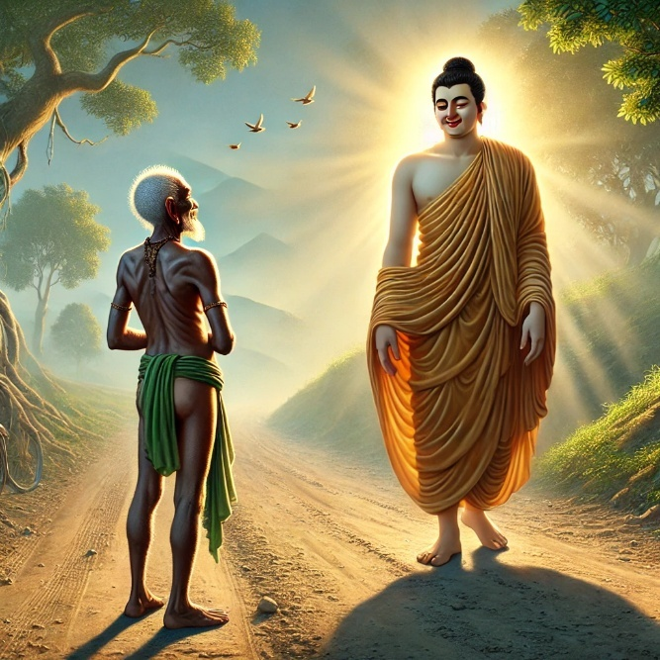

**Upaka’s encounter with the Blessed One on the high road of Gaya [14]**

### Upaka’s Later Realization

According to the commentaries, after parting ways with the Buddha, Upaka continued his life in the world, eventually marrying and having a son. Yet, as he experienced the inevitable suffering of the sensual world, a distant memory resurfaced—the luminous figure he had once met on the road to Gaya. [15]Longing for the peace he had once glimpsed, Upaka finally sought out the Buddha. This time, recognizing the truth, he became his disciple, embarking on the path to liberation

### Dhamma Reflection

The encounter between the Buddha and Upaka reveals the **true nature of a Fully Awakened Buddha (Sammāsambuddha—Jina).** The Blessed One is the **Supreme Being**—one who, without relying on a teacher, through his own wisdom and unshakable resolve, discovered the path to complete liberation from suffering.

This unparalleled realization is among the **nine noble qualities** of the Buddha, which we have previously discussed (see **Section 4**).

### The Buddha: The Discoverer of the Path

Venerable Ānanda affirmed this truth in his reverential words: [16]

**"The Blessed One, accomplished and fully enlightened,**  
**is the arouser of the unarisen path,**  
**the producer of the unproduced path,**  
**the declarer of the undeclared path.**  
**He is the knower of the path, the finder of the path,**  
**the one skilled in the path..."**

Through his supreme wisdom, he illuminated the way for the world, enabling others to follow the path he had revealed.

## Reunion with the Five Ascetics

At the end of his long journey, the Blessed One entered the **Deer Park at Isipatana, Varanasi**, where the **five ascetics**—[17]Koṇḍañña, Vappa, Bhaddiya, Mahānāma, and Assaji—had taken residence.

Seeing the Buddha approaching from a distance, they did not recognize that he had attained supreme enlightenment. Recalling how he had abandoned extreme austerities, they made an agreement: *[18]*

**“***Friends, here comes the recluse Gotama, who once lived with us in hardship, but later abandoned his striving and turned to a life of comfort. Let us not rise to greet him, nor offer him homage, nor receive his bowl and robe. But, let us prepare a seat. If he wishes, he may sit.”*

Yet, when the Blessed One drew near, something profound stirred within them. The radiant presence of the Buddha, filled with boundless **wisdom, love, and compassion**, softened their hearts. Despite their prior resolution, they instinctively rose to greet him.

They took his **bowl and robe**, **prepared a seat**, and **offered water** to wash his feet. Still unaware that they were standing before the **Fully Awakened One**, they addressed him as **"friend" (āvuso).**

Little did they know that their lives—and the course of history—were about to change forever.

At last, the Blessed One’s words touched the hearts of the five ascetics. Their initial scepticism faded, and they inclined their minds to listen deeply. Seeing their readiness, the Buddha declared:

**“…Then listen. I am perfected and fully awakened.**  
**I have discovered the deathless.**  
**I will instruct you and teach you the Truth.**  
**When you practice as instructed, you will soon realize,**  
**with your own insight, the supreme goal of the spiritual life—**  
**the very reason why the noble ones go forth into homelessness.”** *[19]*

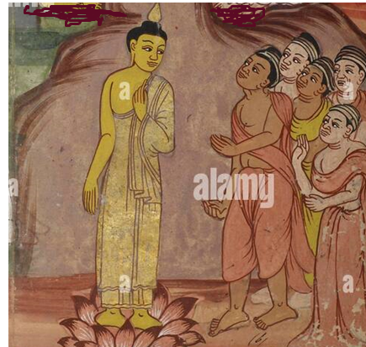

**Five ascetics meeting the Buddha at Deer Park in Isipatana** [20]

# The First Sermon: Setting in Motion the Wheel of Dhamma **[21]**

Thus, on the **Full Moon Day of Āsāḷha**, at the **Deer Park in Sarnath, Varanasi**, the Blessed One delivered his first discourse—the **Dhammacakkappavattana Sutta (The Setting in Motion of the Wheel of Dhamma).** [22]

Here, the Buddha **revealed the essence of his realization**—the **Four Noble Truths**, the foundation upon which the entire Dhamma rests. He explained: [23]

* **The Truth of Suffering** (dukkha)
* **The Truth of the Cause of Suffering** (samudaya)
* **The Truth of the Cessation of Suffering** (nirodha)
* **The Truth of the Path leading to the End of Suffering** (magga)

Everything the Buddha taught thereafter was an elaboration of these four truths.

The Middle Path: The Way to Liberation*[24]*

Through his own arduous journey, the Buddha realized the **futility of extremes**—neither indulgence in sensual pleasures nor self-mortification leads to liberation. He proclaimed the Middle Way (Majjhima Paṭipadā), the path that led him to enlightenment:

*“Bhikkhus, there are two extremes that should be avoided by one who has gone forth.  
What two? The pursuit of sensual pleasures—base, low, and ignoble.  
And the pursuit of self-mortification—painful, futile, and unbeneficial.  
Avoiding both these extremes, the Tathāgata has realized the Middle Way,  
which gives rise to vision and knowledge, leading to peace, enlightenment, and Nibbāna.”*

He then revealed the **Noble Eightfold Path**, the practical way to realize the truth and attain liberation:

* **Right View** (Sammā Diṭṭhi)
* **Right Intention** (Sammā Saṅkappa)
* **Right Speech** (Sammā Vācā)
* **Right Action** (Sammā Kammanta)
* **Right Livelihood** (Sammā Ājīva)
* **Right Effort** (Sammā Vāyāma)
* **Right Mindfulness** (Sammā Sati)
* **Right Concentration** (Sammā Samādhi)

This, the Buddha declared, is the **Middle Path that leads to the cessation of suffering and the ultimate peace of Nibbāna.**

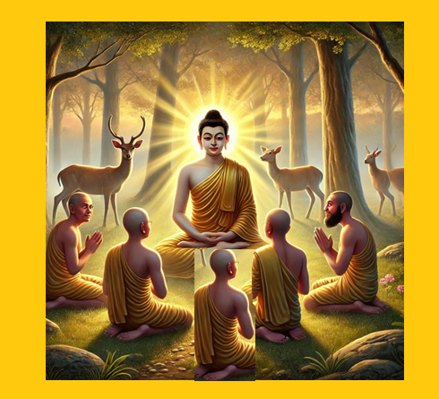

**The First Sermon at**[**Sarnath**](https://en.wikipedia.org/wiki/Sarnath)**, Isipatana - The Dhammacakkappavattana Sutta [25]**

### The First Awakening in the Buddha’s Dispensation

The five ascetics listened intently, absorbing the profound truth. Among them, Venerable Koṇḍañña was the first to awaken[26]. As the Blessed One concluded his teaching, Koṇḍañña experienced the stainless vision of the Dhamma (Dhamma-cakkhu).

He realized the impermanent nature of all things**,** seeing deeply:

**“Whatever has a beginning must also have an end.”** *[27]*

The Buddha, seeing this first breakthrough, rejoiced:

**“Koṇḍañña has understood! Indeed, Koṇḍañña has understood!”**

From that moment, **Venerable Koṇḍañña became the first stream-winner (sotāpanna)**—the first being to enter the path to Nibbāna in the Buddha’s dispensation. Thus, the Wheel of Dhamma, once set in motion, **would never stop turning.**



**The Middle Way -Noble Eightfold Path**

## The Unstoppable Truth of the Dhamma

As the Blessed One expounded his first sermon, a profound transformation swept through the universe. The Devas and Brahmas rejoiced, their voices resounding across the ten thousandfold world systems:

**“At Bārāṇasī, in the Deer Park of Isipatana, the Blessed One has set in motion the unsurpassed Wheel of the Dhamma— a wheel that no one in this world—Māra, Brahmā, or anyone else—can ever stop!”**

At that very moment, a mighty cosmic tremor shook the worlds—the heavens and the earth quaked and trembled. A radiance, more glorious than the divine splendour of the Devas, spread in all directions, illuminating the vastness of existence. [28]

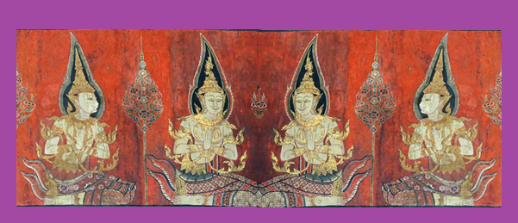

**The Devas and Brahmas listening to the first sermon at Isipatana [29]**

### The Dhamma Continues to Guide the World

According to tradition, countless Devas and Brahmas listening to this discourse attained various stages of noble realization. [30] Even though the Buddha has long since passed away, his Dhamma remains like a lighthouse, casting its radiant beam across the darkness of ignorance, guiding beings toward liberation.

Another remarkable truth is that many celestial beings who heard the first sermon of the Buddha continue to practice the Dhamma even now—in this very world, unseen by human eyes, yet walking the noble path.

# The Profound Importance of the Four Noble Truths

## The heart of the Buddha’s first sermon was this:

Understanding the Four Noble Truths is the key to breaking free from saṁsāra—the cycle of suffering—and attaining Nibbāna. To attain Right View (Sammā Diṭṭhi)—the first step on the Noble Path—is to glimpse the Truth that leads to awakening. The Buddha himself emphasized that merely grasping the Four Noble Truths can transform one’s destiny, ensuring a meaningful, joyful life and a fortunate rebirth:

*“Bhikkhus, those beings are few who, when they pass away as humans,  
are reborn again among humans. But those who pass away and are reborn in lower realms are many. Why is this so? Because they have not realized the Four Noble Truths.”*[31]

Thus, the Dhamma is timeless, ever-present, and ever-available for those who seek the way beyond suffering. Even today, whoever earnestly contemplates and realizes these truths sets foot on the path walked by the Awakened One himself.

# Other Discourses Delivered by the Buddha During this Period

According to the commentaries and other sources, the Buddha delivered two significant discourses shortly after his first sermon.[32]

### 1) Hemavata Sutta (or Sātāgira Sutta) – (Snp 1.9)

This discourse is recorded in the Sutta Nipāta, though its exact time of delivery is not explicitly mentioned. However, one tradition states that the Buddha preached the Dhammacakkappavattana Sutta just before sunset on the full-moon day of Āsāḷha, and at midnight, he delivered the Hemavata Sutta to two powerful Yakkha Devas, Hemavata and Sātāgira. [33]

The sutta opens with **Yakkha Sātāgira** inviting his friend **Hemavata** to meet the Buddha: [34]

*“Today is the fifteenth, the Uposatha day,  
a celestial night has arrived.  
Come, let us see Gotama,  
the teacher of perfect name.”*

Profound Teachings from the Hemavata Sutta[35]

In this discourse, the Buddha illuminates the **qualities required to cross the ocean of saṁsāra**.

Hemavata asks the Blessed One:

*“Who here crosses the flood?  
Who here crosses the sea?  
Who does not sink in the deep,  
which is without foothold, without support?”*

The Buddha replies with words of deep wisdom:

***“One accomplished in pure conduct,******endowed with wisdom and firm concentration,******self-reflective and ever mindful,******crosses the flood so hard to cross.***

***One who has abandoned sensual craving,******who has severed all fetters,******who has utterly destroyed delight in existence—******he does not sink in the deep.”*** [36]

This teaching underscores the **essential virtues of wisdom, discipline, and mindfulness**, which lead to liberation from the endless cycle of birth and death.

### The Remarkable Faith of Kuraraghara Kāḷī

A fascinating event associated with this discourse is the spontaneous realization of a laywoman named Kuraraghara Kāḷī. [37]

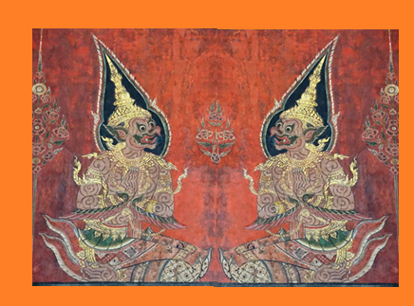

**Yakkha Sātāgira and Yakkha Hemavata discussing the qualities of the Buddha [38]**

Before reaching the Buddha, Yakkha Sātāgira described the Buddha’s noble qualities to his friend Hemavata as they travelled through the sky. Their conversation was overheard by Kāḷī,who had never seen the Buddha nor listened to his teachings. Yet, merely hearing about his supreme qualities filled her with profound joy, and due to her past meritorious deeds, she attained stream-entry (sotāpatti)—the first stage of awakening.

In the Aṅguttara Nikāya, the Buddha later praised her as the foremost among female lay followers whose faith was established purely through hearing:

*“…Among my female lay followers, the foremost in confidence based on hearsay  
is Kāḷī of Kuraraghara.” [39]*

This extraordinary account reveals that the Dhamma has the power to transform and awaken beings, even without direct instruction, when the heart is open and ripe for realization.

### 2) Nālaka Sutta [40]

According to the scriptures, this profound discourse was delivered to Ascetic Nālaka, the nephew of the great seer Asita. Asita was the sage who, upon seeing the infant PrinceSiddhartha, predicted that he would one day become a Fully Enlightened Buddha (see: Section 2).

Recognizing the rare opportunity that would arise in the future, Asita advised his nephew to renounce worldly life and live as an ascetic, waiting for the appearance of the Buddha. He instructed Nālaka with these words:

**“**When you hear the word ‘Buddha’ from another,  
and hear that ‘one who attained enlightenment  
reveals the foremost Dhamma,’  
then seek him out, inquire about his teaching,  
and lead the spiritual life under that Blessed One.” *[41]*

Following his uncle’s guidance, Nālaka sought the Buddha after hearing of his first sermon. The sutta describes his meeting with the Blessed One:

*“Having heard the word about the Conqueror,  
who set in motion the excellent Wheel of the Dhamma,  
he went to see the chief sage and was filled with joy.  
As the time had come to receive Asita’s instruction,  
he humbly asked the noble sage about the path of liberation.”*

### Nālaka’s Realization

According to some sources, the *Nālaka Sutta* was delivered to him after the first sermon, and through its profound wisdom, he attained Arahantship—the highest state of liberation. [42]

### Key Dhamma Reflections from the Nālaka Sutta

This discourse illuminates the qualities of a true sage (Muni-hood)—the essence of one ho has attained wisdom and enlightenment:

*“Be not sluggish in mind, nor let restless thoughts overwhelm you.  
Be pure and unattached, devoted to the spiritual path.  
Seek solitude and remain close to the wise;  
for solitude, they say, is the mark of sagacity.  
If you welcome seclusion,  
your light will shine across the ten directions.”*

A true sage, the Buddha explains, speaks only what is meaningful and beneficial:

*“When the ascetic speaks, his words are relevant and profound.  
Knowing the truth, he teaches the Dhamma—knowing, he speaks wisely.  
Yet, one who truly knows, remains self-controlled,  
and speaks only when necessary.  
That sage is worthy of sagacity;  
that sage has attained the highest wisdom.”*

This sutta offers a timeless reflection on wisdom, restraint, and the transformative power of solitude—qualities that define the awakened ones.

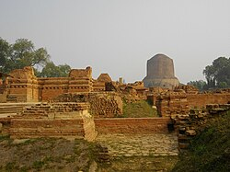

**Dhammekha Stupa at Isipatana-The place where the first sermon was delivered [43]**

# Significant Events at Isipatana After the First Sermon

After delivering the Dhammacakkappavattana Sutta, the Blessed One not only set in motion the Wheel of the Dhamma but also laid the foundation for the monastic community (Saṅgha). Isipatana became the sacred ground where the first disciples attained enlightenment, marking the beginning of the Buddha’s dispensation. [44]

### The First Step Towards Establishing the Monastic Order

Upon hearing the Buddha’s first discourse, the five ascetics—Koṇḍañña, Vappa, Bhaddiya, Mahānāma, and Assaji—were deeply moved. Their doubts vanished, faith arose in their hearts, and they became the Blessed One’s first disciples.

### First Ordination

The *Vinaya Piṭaka* describes how the first ordination in the Buddha’s dispensation took place:

“Aññāsikoṇḍañña had seen the Truth—he had understood, penetrated, and gone beyond all doubt and uncertainty. He approached the Buddha and requested to go forth into the monastic life. The Blessed One replied:

‘Come, monk! The Dhamma is well-proclaimed. Live the holy life for the complete ending of suffering.’ *[45]*

With these words, Koṇḍañña became the first ordained monk (bhikkhu) in the Buddha’s dispensation. *[46]*

The Buddha continued to instruct the remaining four ascetics. As they listened to his teachings: *[47]*

* Vappa and Bhaddiya realized the stainless vision of the Truth and requested ordination.

Mahānāma and Assaji soon followed, receiving ordination in the same way. *[48]*

These five were the pioneers of the monastic community, and together with the Blessed One, they formed a gathering of six enlightened beings in the world—a moment of great significance in human history.

## The Discourse on Non-Self (Anatta Lakkhaṇa Sutta) [49]

After establishing them in the Dhamma, the Buddha expounded the Anatta Lakkhaṇa Sutta, the discourse that revealed the nature of non-self (anattā). Upon hearing this profound teaching, the five bhikkhus attained Arahantship—the final liberation from all defilements.

The Buddha proclaimed:

Any kind of form, feeling, perception, mental formations, and consciousness (the five aggregates) With right understanding, one should see them as: ***[50]***

***‘This is not mine; this is not me; this is not myself.’***

Through deep contemplation of these truths, they fully realized the impermanent (anicca), unsatisfactory (dukkha), and non-self (anatta) nature of existence—the Tilakkhaṇa (Three Universal Characteristics).

## The First Five Arahant Disciples

With the realization of non-self, the Five Bhikkhus became the first Arahants—fully liberated beings free from all defilements. The Buddha rejoiced and declared:

“*The bhikkhus of the group of five, thus taught and instructed by me, being themselves subject to birth, having understood the danger in what is subject to birth, seeking the unborn supreme security from bondage—Nibbāna—attained that very Nibbāna.”* *[51]*

At that moment, the world witnessed six Arahants walking the earth—the Buddha and his first five enlightened disciples. The Dhamma had truly taken root, and the light of liberation had begun to spread.

## Reflections on This Historic Moment

This sacred event at Isipatana was not merely the beginning of a monastic order, but the dawning of a new era of wisdom and liberation. The truths revealed in the Anatta Lakkhaṇa Sutta continue to guide countless beings towards freedom from suffering**.**

The Three Universal Characteristics (Tilakkhaṇa)

impermanence, suffering, and non-self—are the heart of the Dhamma. Those who truly understand them walk the path toward Nibbāna, the ultimate peace.

Thus, the sacred land of Isipatana became the birthplace of both the Saṅgha and the light of the Dhamma, illuminating the path for all beings seeking liberation.

# The First Vassa:The Blessed One’s First Rainy Season at Age Thirty-Five

Following the Āsāḷha Full Moon, when the Blessed One set the Wheel of the Dhamma in motion, the time soon arrived for the Rainy Season Retreat (Vassa)—a period of deep contemplation and spiritual discipline. According to scriptures and tradition, the Buddha spent his first vassa at Barnas, Isipatana, the sacred Deer Park, together with his first five disciples. [52]

# Evidence regarding the first vassa

The Vinaya Piṭaka confirms this important event, marking the first monastic retreat in the Buddha’s dispensation. This retreat was not merely a time of residence but a period ofprofound transformation, as new disciples were drawn to the Blessed One’s teachings. Following two events confirmed that the Blessed One spend his first vassa at Barnas, Isipatana.

### 1) The Meeting with Yasa – The Sixth Arahant **[53]**

One of the most significant events during this first vassa was the encounter between the Buddha and Yasa, the son of a wealthy family from Bārāṇasī. The Vinaya Piṭaka provides a vivid account of Yasa’s awakening:

*“… While Yasa was spending the four months of the rainy season in the rainy-season house, he fell asleep before his attendants. When he awoke, he saw them still asleep, lying in disarray, and it appeared to him like a charnel ground before his very eyes. Overcome with a deep sense of repulsion, a feeling of renunciation arose in him…”*

Realizing the impermanence of worldly pleasures, Yasa left his home and wandered through the night, arriving at Isipatana, where he encountered the Buddha. The Blessed One, with his boundless wisdom and compassion, preached the Dhamma to Yasa, revealing the truth of suffering and the path to liberation.

Upon hearing the sublime teaching, Yasa was deeply moved and became a disciple of the Buddha. [54] Soon after, through diligent practice, he attained Arahantship, becoming the sixth fully enlightened disciple in the world.

This moment demonstrated the timeless power of the Dhamma—how even one glimpse of impermanence (anicca) could awaken a sincere seeker, leading them from worldly disillusionment to the path of liberation. [55]

### 2) The Buddha’s Reflection at the End of the First Vassa

Upon completing his first Rainy Season Retreat, the Blessed One gathered the monks and spoke these profound words recorded in the Vinaya Piṭaka:

*“Through wise attention and wise right effort, I have reached the supreme freedom, realized the supreme freedom. And you, monks, have done the same.” [56]*

These words hold deep significance. They remind us that liberation is not granted by another—it is realized through one’s own effort, wisdom, and practice. The monastic retreat (Vassa) was not simply a period of rest but a time of intense practice, insight, and realization.

The both events mentioned in the scriptures as stated above confirm that the Buddha spent his first rainy season in Deer Park, Isipatana.

# Other Testimonies of the Buddha’s First Vassa

Various sources provide further insights into the spiritual impact of this period:

1️ A Verse from the Commentaries:

“After setting the Wheel of the Dhamma rolling at Isipatana, he made 180 million Brahmas and Devas imbibe the immortal ambrosia During his first Rains Retreat.” [57].

*( Paṭhamaṁ Vassaṁ Isipatane Dhammacakkaṁ pavattetvā*

*aṭṭhārasa Brahmakoṭiyo amatapānaṁ pāyetvā).*

This reveals that the Dhamma was not confined to the human world alone—it reverberated across the cosmos, reaching even the highest realms. The Brahmas, celestial beings of great virtue, rejoiced and were deeply moved by the Buddha’s teachings.

2️ A Poetic Description of the Buddha’s Presence at Isipatana:

“The Excellent, Victorious (Buddha) Sun,  
Illuminated those who were receptive—like a lotus field opening to the morning light—  
With the radiant beams of the True Dhamma,  
While dwelling for the first Rains Retreat in the Deer Park near Bārāṇasī.” [58]

(*Pavaro Jina-aṁsu-māli Saddhamma-raṁsi-nikarehi veneyya-paṅkaja-vanāni vikāsayanto, paṭhamamhi Vasse, Bārāṇasimhi nagare Miga-Kānanamhi vāsaṁ akāsi.)*

This imagery conveys the Buddha’s presence as a radiant sun, awakening those ready to receive the Dhamma. Just as lotus flowers bloom when touched by sunlight, beings with good kamma opened their hearts to the truth, attaining spiritual awakening.

### 3️ Another Testimony:

“While the Buddha was taking residence at Isipatana for his vassa-observance,  
He continued to expound the Dhamma, teaching the Anatta Lakkhaṇa Sutta to the Five Bhikkhus and the Nālaka Sutta to the ascetic Nālaka.” *[59]*

This emphasizes that the Buddha’s first vassa was not merely a period of seclusion but an active time of teaching, inspiring, and guiding seekers on the path to liberation.

# Reflections on This Historic Vassa

The first vassa at Isipatana was not just a significant event in the Buddha’s life—it was a turning point for the world. It marked:

* The first monastic retreat, setting a precedent for future monks and practitioners.  
* The transformation of Yasa and others, proving that realization is possible for all who sincerely seek the truth.  
* The radiant spread of the Dhamma, reaching celestial realms and touching countless beings.

This moment serves as a powerful reminder to all practitioners—true freedom is found not in external comforts, but in deep insight, wisdom, and unwavering effort. The path to Nibbāna is open to all who seek it with sincerity, just as it was for Yasa and the Five Bhikkhus.

**Thus, Isipatana became more than a sacred site—it became the very cradle of enlightenment, where the first wave of awakened beings arose, illuminating the world with the light of the Dhamma.**

# Significant Events During the First Vassa

The first Rainy Season Retreat (Vassa) at Deer Park, Isipatana, was a period of immense spiritual transformation and growth. The small assembly of monks who had gathered around the Blessed One blossomed into a thriving community, and the light of the Dhamma began spreading beyond Isipatana, touching the hearts of many.

Through the scriptures, we have gathered the following momentous events that occurred during this first vassa—each marking a turning point in the history of the Buddha’s dispensation. [60]

## The Expansion of the Bhikkhu Saṅgha and Lay Followers [61]

During this time, the Buddha’s enlightened disciples grew in number. By the end of the retreat, the Sangha had expanded to sixty fully liberated arahants—beginning with the first five bhikkhus, followed by Yasa and his fifty-four companions.

**The first vassa at Isipatana was not only the beginning of the monastic order but also the first instance of devoted lay disciples taking refuge in the Triple Gem.**

The *Vinaya Piṭaka* records that Bhikkhu Yasa’s parents and his former wife, upon listening to the Dhamma, became stream-enterers (sotāpannas), securing their path toward liberation.

The Sangha was no longer just five monks in a secluded grove—it was a growing spiritual community, a beacon of wisdom for both renunciants and householders alike. [62]

The First Progressive Dhamma Talk—Building a Path to Liberation

One of the Buddha’s unique methods of teaching was his gradual approach to the Dhamma (Anupubbi Katha). Before revealing the profound truths of the Four Noble Truths, he would prepare the listener’s mind by first speaking on subjects they could relate to:

* The virtues of generosity (dāna)  
* The benefits of moral conduct (sīla)  
* The realms of heavenly bliss  
* The dangers of worldly pleasures  
* The liberating nature of renunciation

Only when he sensed that the listener’s mind was softened and ready, free from resistance, would he reveal the deeper truths of suffering, its cause, its cessation, and the path leading to liberation.

This powerful teaching method can be seen in Yasa’s awakening: [63]

***“…While sitting right there, Yasa experienced the stainless vision of the Truth: ‘Anything that has a beginning has an end”*** [64]

This realization—of impermanence (anicca)—was the first step in his journey to Arahantship.

The Buddha was not merely imparting knowledge—he was leading seekers on an inner journey, preparing their minds for deep insight.

# Events Following the First Vassa

Once the first rainy season had ended, the Buddha did not remain in Isipatana. True to his boundless compassion for all beings, he and his newly ordained bhikkhu disciples set out on a mission to spread the Dhamma. [65]

### The First Missionary Service—Sending the Disciples to Teach [66]

At this critical moment, the Buddha addressed the sixty arahants with these historic words:

*“Go forth, O monks, for the welfare of the many, for the happiness of the many, out of compassion for the world, for the benefit and welfare of gods and humans.”*

*“Proclaim the Teaching that is good in the beginning, good in the middle, and good in the end—well-articulated and complete in every way. There are beings with little dust in their eyes who are lost because they have not heard the Dhamma. There will be those who understand.”*

*( desetha bhikkhave, dhammam ādikalyānam majejha kalyānam pariyosāna kalyānam sāatham sabyañjanam kevalaparipunam brahamacariyam pakāsetha).*

This moment marked the **first great Dhamma-mission in history**—the disciples were no longer students, but messengers of liberation, carrying the light of wisdom to every corner of the land.

**The Buddha’s instruction emphasized an essential truth:**

The Dhamma is not meant to be hoarded—it is meant to be shared.

It is a gift to the world, and those who have realized its truth must extend it with boundless compassion.

## The Profound Meaning of “Good in the Beginning, Middle, and End”

In this address, the Buddha also described the **threefold excellence of the Dhamma**—it is **good in the beginning, in the middle, and in the end**. But what does this mean?

The *Visuddhimagga (Path of Purification)* provides deep insight into this profound phrase: [67]

1️ **Good in the Beginning—Virtue (Sīla)**

* The Dhamma begins with **moral purity**.
* Just as a tree **takes root in rich soil**, a **virtuous life provides the foundation** for higher spiritual attainments.
* Those who are virtuous **have no remorse** and cultivate peace.

2️ **Good in the Middle—Samādhi**

* Once **virtue is established**, deep meditation **calms the mind**, making it firm and **unshakable like a mountain**.
* **Samādhi** gives rise to **supernormal insights** and the **direct experience of truth**.

3️ **Good in the End—Wisdom (Paññā)**

* Wisdom **cuts through all illusions**, leading to the realization of **Nibbāna**.
* A mind perfected in wisdom remains **unmoved by praise or blame**, just as a mighty rock stands firm against the wind.

As the Dhammapada says:

**“Just as a solid, massive rock remains unshaken by the wind,**  
**So too, the wise remain immovable in the face of blame and praise.”[68]**

Another interpretation states: **[69]**

* Sīla (virtue) and Samādhi form the beginning.
* Vipassanā (insight) and the Path (Magga) form the middle.
* The Fruition (Phala) and Nibbāna form the end.

Each aspect of the path is complete in itself, yet they all flow together toward the ultimate freedom from suffering.

# Reflections on This Historic Vassa

The first Rainy Season Retreat at Isipatana was not merely an event in history—it was the beginning of an unfolding transformation that would reshape the world. It marked:

* **The birth of a thriving Saṅgha**, as sixty enlightened beings stood ready to spread the Dhamma.  
* **The first lay disciples**, demonstrating that liberation is available to all—whether monks or householders.  
* **The first great missionary effort**, carrying the Dhamma beyond Isipatana, ensuring that those with “little dust in their eyes” would hear the truth.  
* **The first structured Dhamma teachings**, revealing a methodical path to wisdom, one that is progressive, transformative, and complete in every way.

### **Dhamma Message**

This moment in time is a powerful reminder for all who walk the path today. The Dhamma is not meant to be hidden—it is meant to illuminate the world.

Like the first sixty arahants who set forth without hesitation, we too can carry this light in our own way—by practicing, by sharing, and by living the truth of the Buddha’s teachings.

## The Wheel of Dhamma was set in motion that day—and it has never stopped turning.

### Summary of section 13-1

* Arrival of the Buddha at Isipatana (completing his first walking tour); delivering important discourses—Dhammacakkappavattana Sutta and Anatta Lakkhana sutta and the important Dhamma messages delivered through those discourses.

* We also saw that another two important suttas—Hemavata and Nālaka suttas were delivered at this time.

* Another important mile stone of Buddhism—the establishment of Bhikkhu Sanga was also happened during this period.

* The Blessed One spent his first vassa at the Deer Park in Isipatana.

* Another significant event was some lay people—family of Yasa (after Thapassu and Ballika (see section: 4) becoming lay followers of the Buddha.

* After the rain retreat the Buddha has sent his bhikkhu sangha on their first missionary service and he himself went to Uruvelā, his second walking Tour.

**In the next section**: 13-2 we are going to see the second walking tour and what important things happened during that time.

### End Notes -Section 13-1

1. Uruvelā: a locality on the banks of the Nerañjarā river, in the neighbourhood of the Bodhi-tree at [Buddhagayā](http://en.wikipedia.org/wiki/Bodh_Gaya). Here, after leaving Āḷāra and Uddaka, the Bodhisatta practised during six years the most severe penances. The place chosen by the Bodhisatta for his penances was called Senānigāma.

   Source: Dictionary of Pāli Proper Names by G.P. Malalasekera, https://www.aimwell.org/DPPN/isipatana.html
2. Brahmā Devas are heavenly beings in Buddhist Cosmology; In Buddhism there is not one Brahma or Great Brahma but many, and they are not immortal. Tradition considered Sahampati Brahma as a protector of Dhamma; he appeared before the Buddha and invited him to teach. At the time of the passing away of the Buddha he was present at Kusinara and praised the qualities of the Buddha. For more information see SN: Brahmasamyutta.
3. VP: Mahākhandhaka: 6 The account of the group five (Translated by ‘Bhikkhu Brahmali.) * This incident is also mentioned in MN:26 (Ariyapariyesenā sutta)
4. These two were famous teachers at the time of Ascetic Siddhartha living in Magadha country, see: section: 3, for more details.
5. VP: Mahākhandhaka: 6
6. VP: Mahākhandhaka: 6, this event is also described in MN: 26.
7. Isipatana: an open space near **Bārāṇasī**, the site of the famous Migadāya or Deer Park. It was eighteen leagues from [Uruvelā](https://www.aimwell.org/DPPN/uruvela.html); Isipatana is mentioned by the Buddha as one of the four places of pilgrimage that his devout followers should visit (DN:16). Isipatana was so-called because sages, on their way through the air (from the Himalayas), alight here or start from here on their aerial flight *(isayo ettha nipatanti uppatanti cāti-Isipatanaṃ).* The Migadāya was so-called because deer were allowed to roam about their unmolested: Source: Dictionary of Pāli Proper Names by G.P. Malalasekera, https://www.aimwell.org/DPPN/isipatana.html
8. Original map source: http://wiswo.org/books/footprints/)
9. VP: Mahākhandhaka: 6
10. According to ancient Indian calendar this time is considered mid-June to mid-July. See alos: Chapter 9: The Buddha proceeding to Migadaya: The Great Chronicle of Buddhas by Venerable Mingun Sayadaw.
11. A class of naked [ascetics](https://www.aimwell.org/DPPN/ajivaka.html#01),¹ followers of [Makkhali Gosāla](https://www.aimwell.org/DPPN/makkhali_gosala.html): Source: Dictionary of Pāli Proper Names by G.P. Malalasekera, https://www.aimwell.org/DPPN/isipatana.html
12. VP: Mahākhandhaka: 6 * this event is also described in MN: 26 . * Here it is mentioned that the skin of the Buddha is pure and bright(like gold) —this is one of the signs of a great man, see:section:5.
13. VP: Mahākhandhaka: 6
14. AI generated image.
15. See: MN: Notes: 310: according to MA, Upaka thereafter fell in love with a hunter’s daughter and married her. When his marriage turned out to be an unhappy one, he returned to the Buddha, entered the Sangha, and became a non-returner. He was reborn in the Avı̄ha heaven, where he attained arahantship; see also SN1:50, where the Brahma Deva Ghaṭīkāra, informed the Buddha about Ven. Upaka, a non-returner who was born in Avı̄ha brahmaloka.
16. MN: 108 (Gopakamoggallāna Sutta).
17. Known as Pañcavaggiya. Koṇḍañña was the youngest of the eight brahmins who read the signs on Gotama’s body on the day of the name giving festival. The four others were children of four of the other brahmins. They had been advised by their fathers to watch Gotama’s career and to join him should he renounce the world. This they did, and all five joined in the austerities of Gotama at Uruvelā. When he abandoned his austerities and started to follow the Middle Way, they left him in disappointment. Source: Dictionary of Pāli Proper Names by G.P. Malalasekera, https://www.aimwell.org/DPPN/isipatana.html.
18. VP: Mahākhandhaka:6 and MN: 26 Ariyapariyesena sutta.
19. VP: Mahākhandhaka 6.
20. Source: alamy.
21. SN56:11. .* Per Bhikkhu Bodhi: “What follows is the Buddha’s first sermon, recorded in the narration of his ministry at Vin I 10-12. The sutta is analysed at MN No. 141 and Vibh 99-105, and commented upon at Vism 498-510 (Ppn 16:32-83) and Vibh-a 93-122. For a detailed explanation according to the method of the commentaries, see Rewata Dhamma, *The First Discourse of the Buddha*”. See: SN: Note:380.
22. The Buddha delivered his 1st sermon on the Full Moon night of the month Ãsāla. See: Chapter 9: The Great Chronicle of Buddhas by Venerable Mingun Sayadaw.
23. The discourse is given in VP: Mahākhandhaka:6 & SN56: 11.* For more information of the Four Noble Truths, see: SN:56-Saccasaṁyutta.
24. SN56: 11
25. AI generated image
26. Aññākoṇḍañña Thera became the first stream winner of the dispensation of the Buddha, he was declared the foremost of bhikkhu disciples in seniority. For more information see: ‘Great Disciples of the Buddha by Bhikkhu [Nyanaponika](https://www.amazon.com.au/Nyanaponika/e/B001HPZUT8/ref=dp_byline_cont_ebooks_1)  & [Hellmuth Hecker](https://www.amazon.com.au/s/ref=dp_byline_sr_ebooks_2?ie=UTF8&field-author=Hellmuth+Hecker&text=Hellmuth+Hecker&sort=relevancerank&search-alias=digital-text), Wisdom publication.
27. SN56: 11.
28. SN56:11.
29. Author: Ãnandajoti Bhikkhu: https://www.flickr.com/photos/anandajoti/35252943415
30. Chapter 9: The Great Chronicle of Buddhas by Venerable Mingun Sayadaw.
31. SN56:102. * For more information of the Four Noble Truths see: section 10.
32. Chapter 10: The Great Chronicle of Buddhas by Venerable Mingun Sayadaw.
33. It seems Sātāgiri was with other devas who were rejoicing the first sermon of the Buddha a [Maha Buddhavamsa—The Great Chronicle of Buddhas](https://www.wisdomlib.org/buddhism/book/the-great-chronicle-of-buddhas) by Ven. Mingun Sayadaw .t Isipatana. He had a good friend another yakka deva called Hemavata, desiring to share the Dhamma with his friend, he left Isipatana searching his friend. By the time Sātāgiri came back to Isipatana he came to know the Blessed One already deliverd the 1st sermon. So, during the mid night they approached the Buddha, and the Buddha delivered this sermon to them See: [Maha Buddhavamsa—The Great Chronicle of Buddhas](https://www.wisdomlib.org/buddhism/book/the-great-chronicle-of-buddhas)- Chapter 10 - Hemavata Sutta. * After listening to the discourse both the yakka devas were established in stream entry.
34. “ He and his friend, [Hemavata](https://aimwell.org/DPPN/hemavata.html), were two of the twenty-eight leaders of the *yakkhas.* They had both been monks in the time of [Kassapa Buddha](https://aimwell.org/DPPN/kassapa_buddha.html), but had been guilty of deciding wrongly in the dispute which arose between Dhammavādī and Adhammavādī, hence their birth as *yakkhas,* Sātāgira in Sātapabbata, and Hemavata in **Himavā**. They recognised each other at the*yakkha* assembly in the Bhagalavatī-pabbata, and promised to inform each other if, in their lives, they came across anything of interest.”: Source: Dictionary of Pāli Proper Names • G.P. Malalasekera.
35. Snp:1.9 (Hemavata Sutta, translated by Bhikkhu Bodhi).
36. These are the qualities of an arahant, see: Snp: 1.9 (Hemavata sutta, translated by Bhikkhu Bodhi). * Similar verses are in SN1:1 (Crossing the floof Sutta).
37. **Chapter 10** of the above text give details of this event: The lady who was pregnant with a child (who later became venerable Sona Kutikanna) residing with her parents in Rajagaha heard the dialogue between the 2 yakkas was rejoiced. AN: Note: 148, p. 588 says: A supporter of Mahākaccāna, she converses with him in **10:26**. Mp says that she gained trust when she heard two yakkhas (spirits) speaking praise of the Three Jewels while traveling through the sky. She thereupon attained the fruit of stream-entry.
38. Author: Ãnandajoti Bhikkhu: https://www.flickr.com/photos/anandajoti/35252943415
39. AN1: 267 * A supporter of Mahākaccāna, she converses with him in **10:26**. Mp says that she gained trust when she heard two yakkhas (spirits) speaking praise of the Three Jewels while traveling through the sky. She thereupon attained the fruit of stream-entry, see: AN: Note:148
40. Snp:3.11 (Nalaka Sutta).
41. Ibid.
42. The Devas who were listening to the 1st discourse went to see the Hermit Nalaka who was residing in a Forrest in Himalaya to report that the Buddha has arisen in the world. Nalaka who was the nephew of Ascetic Asita (See: section1 & 2 ) urged him to be an ascetic and waits for Prince Siddhartha to become the Buddha. Hence, ascetic Nalaka came to see the Buddha who preached him Nalaka sutta (Snp:3.11) and the end of the discourse he became a stream winner. **See** Chapter 11 of [Maha Buddhavamsa—The Great Chronicle of Buddhas](https://www.wisdomlib.org/buddhism/book/the-great-chronicle-of-buddhas).
43. Source: <https://en.wikipedia.org/wiki/Sarnath>
44. When the Buddha delivered his 1st sermon Koṇḍañña became a stream winner. See: VP: Mahākandaka: 6: Translated by Bhikkhu Brahmali, SN:56:Dhammacakkappavattana Sutta
45. “Come Monk” —Ehi Bhikkhu”. Here it says that when the Buddha pronounced “Ehi Bhikkhu”, immediately his (Venerable Koņdaññ’s original appearance vanished and he was transformed into a bhikkhu, with the shaved head and body donned in the robes etc. This was due to the merits he has done in his previous lives. see: Chapter 9: [Maha Buddhavamsa—The Great Chronicle of Buddhas](https://www.wisdomlib.org/buddhism/book/the-great-chronicle-of-buddhas).
46. VP: Mahakhandaka: 6.
47. Ibid:
48. Ibid.
49. VP: Mahākandaka: 6:, SN:22:59. *This is the second discourse of the Buddha, recorded at Vin I 13-14. The five bhikkhus are the first five disciples, who at this point are still trainees (*sekha*). They attain arahantship by the end of the discourse. Spk: Following the Dhammacakkappavattana Sutta (the first sermon), given on the full-moon day of Āsaḷha (July), the five were gradually established in the fruit of stream-entry. On the fifth of the following fortnight, he addressed them, thinking, “Now I will teach them the Dhamma for the destruction of the taints.”, see: SN: Note: 90
50. SN22: 59 (Anatta-Lakkana sutta).
51. MN: 26 (Ariyapariyesanā Sutta).
52. Baranas (Varanasi) was the city of Kasi one of the 16 states-during the life of the Buddha there were 16 states in northern part of ancient India. see: Maps
53. Yasa Thera: he was the son of a very wealthy treasurer of Bārāṇasī, and was brought up in great luxury, living in three mansions, according to the seasons and surrounded with all kinds of pleasures. Impelled by antecedent conditions, he saw one night the indecorum of his sleeping attendants, and, greatly distressed, put on his gold slippers and left the house and the town, non-humans opening the gates for him. He took the direction of Isipatana, exclaiming: “Alas! What distress! Alas! What danger!” The Buddha saw him in the distance and called to him, “Come Yasa, here is neither distress nor danger.” Filled with joy, Yasa took off his slippers and sat beside the Buddha. Source: Dictionary of Pāli Proper Names • G.P. Malalasekera
54. See: VP: Mahākandaka:7:
55. Ibid.
56. See: VP: Mahākandaka:10:
57. Source 1: Madhuratthavilāsinī (Buddhavaṁsatthakathā) of Bhadantâcariya Buddhadatta Mahathera: Translated by I. B. Honer, 1946.
58. Source 2: Jinacaritaṁ, The Life of the Victorious Buddha, translated by Bhikkhu Anandajoti.
59. See: Chapter 12: The Great Chronicle of Buddhas by Venerable Mingun Sayadaw
60. VP: Mahākandaka :7.
61. VP: Mahākandaka 7: described the story of Yas and his friends going forth.
62. Ibid. * These 3 considered as 1st lay followers who took refuge in Triple Gem.
63. Ibid. It is mentioned here that listining to the Dhamma talk of the Buddha Yasa became a stream winner.
64. VP: Mahākandaka 7.
65. Ibid.
66. See: SN5: 5 & VP: Mahākandaka 8, Translated by Bhikkhu Brahmali.
67. Chapter1, Path of Purification (Translated by Bhikkhu Ñanamoli). * There is a longlist of this, here we have shown a few.
68. Dhp:81
69. Chapter 13 : The Great Chronicle of Buddhas by Venerable Mingun Sayadaw.